### ME5413-Homework Group number :16

LI BO ：A0269522Y XUE HAOYAN: A0268454U

**Task 1: Write the ICP Algorithm for Matched Point Cloud**

The ICP algorithm for matched point cloud can be divided into five steps:

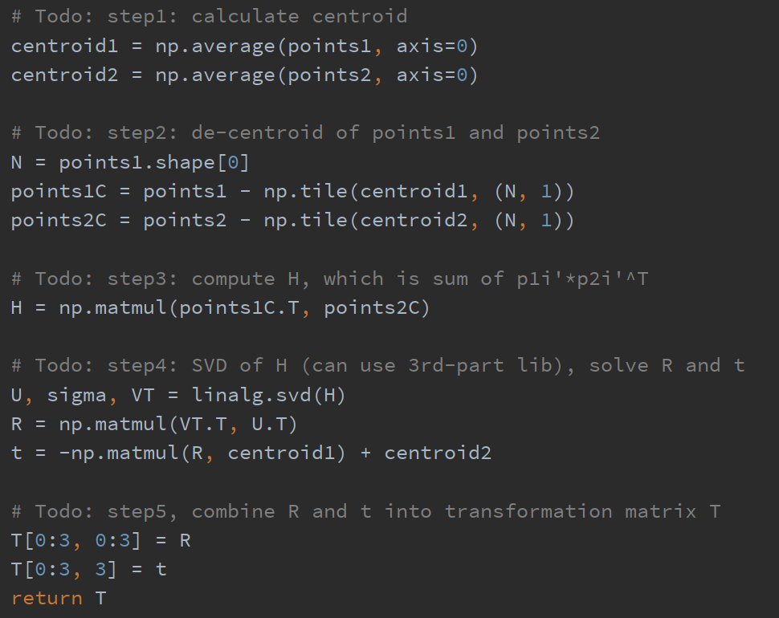

Figure 1.1 Five steps

The obtained transformation matrix is shown below.

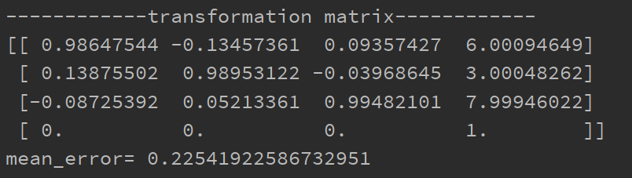

Figure 1.2 Transformation matrix

The screenshot of visualization result is shown below.

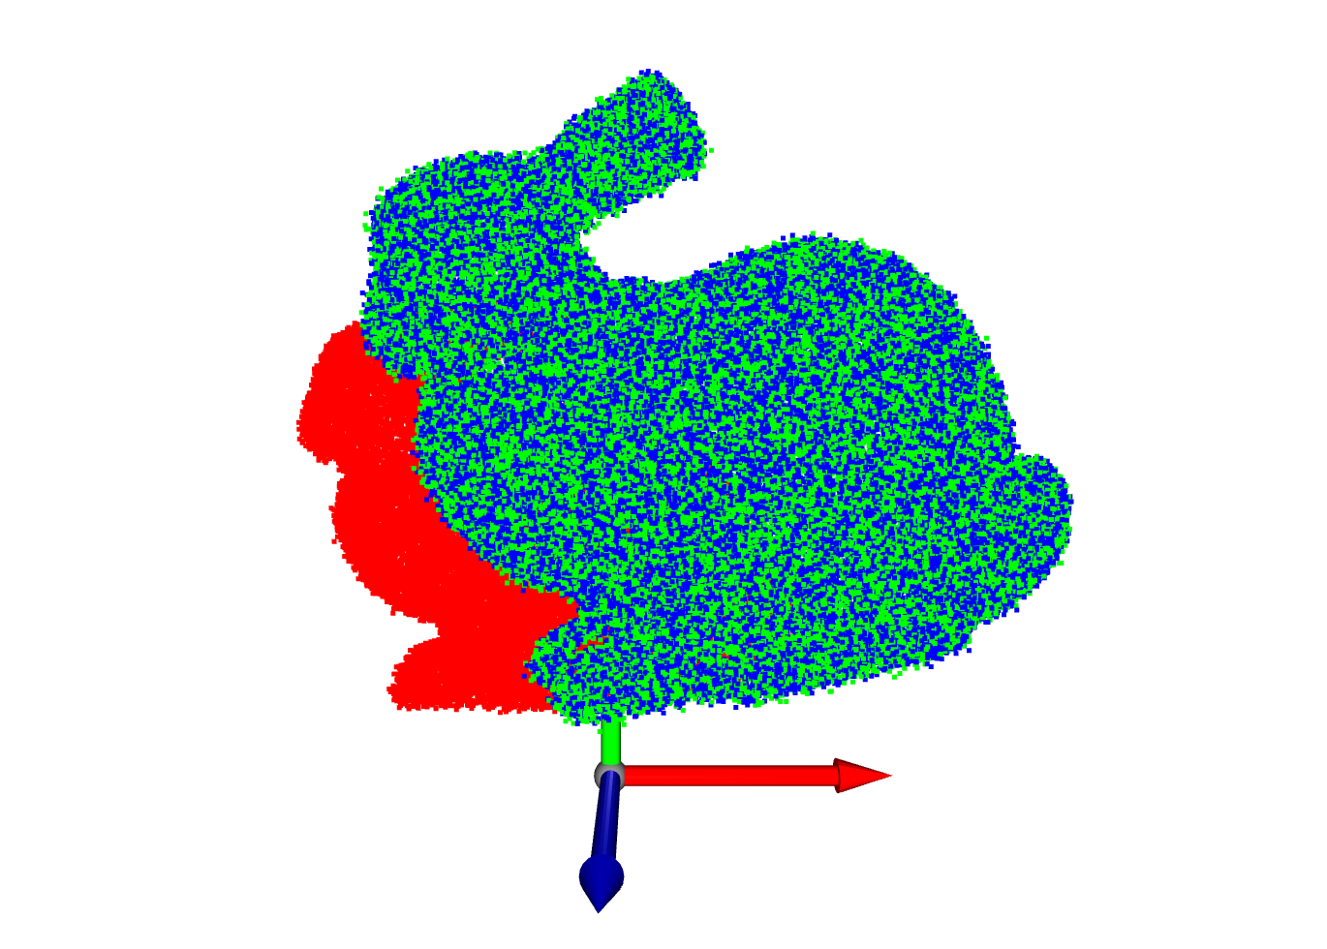

Figure 1.3 The screenshot of visualization result

**Task 2: Write the ICP Algorithm for Unmatched Point Cloud**

The ICP algorithm based on SVD is used to register the point cloud. The ICP algorithm is an iterative closest point algorithm, which finds the best rigid body transformation T by iteratively calculating the minimum square error between the two point clouds, so as to register the two point clouds. This function receives two unmatched point clouds points1 and points2, as well as the number of iterations n_iter and the threshold threshold as input parameters.

The specific implementation process is as follows:

1. Copy the two input point clouds to the points_1 and points_2 variables, and initialize the accumulated transformation matrix T_accumulated as a 4x4 identity matrix.

2. Create an o3d visualization window and visualize the second point cloud in blue.

3. For each loop iteration, first find the nearest point in points_2 for each point in points_1, and generate points_2_nearest, here KDTree is used to achieve fast nearest neighbor search.

4. Call the icp_core function to calculate the transformation matrix T, and then accumulate T into T_accumulated.

5. Transform points_1, and then calculate the average distance mean_distance. If the mean_distance is less than the set threshold, exit the loop and complete the registration. Otherwise, continue loop iterations.

6. Visualize the transformed points_1, then update points_1.

7. Record the running time of the algorithm, and display the final registration result in the visualization window.

The number of iterations and the threshold are two important parameters in the ICP algorithm, which need to be adjusted according to specific application scenarios and data characteristics.

The determination of the number of iterations is generally determined through experiments and experience. Generally speaking, the more iterations of the ICP algorithm, the higher the final registration accuracy will be, but at the same time it will increase the calculation time and calculation burden. Therefore, in practical applications, it is necessary to determine the number of iterations according to the actual situation. If the registration result has converged, the iteration can be ended early. Additionally, you can avoid situations where the algorithm gets stuck in an infinite loop by setting an upper bound on the maximum number of iterations.

The determination of the threshold can be realized by adjusting the threshold of the average distance. Generally speaking, when the average distance is less than a certain set threshold, it can be considered that the registration has been completed. The setting of the threshold needs to take into account factors such as the size of the point cloud, the noise level, and the density of the point cloud. If the threshold is set too small, the algorithm may fall into a local optimal solution, and if it is set too large, the algorithm may fail to converge.（n_iter=30, threshold=1）

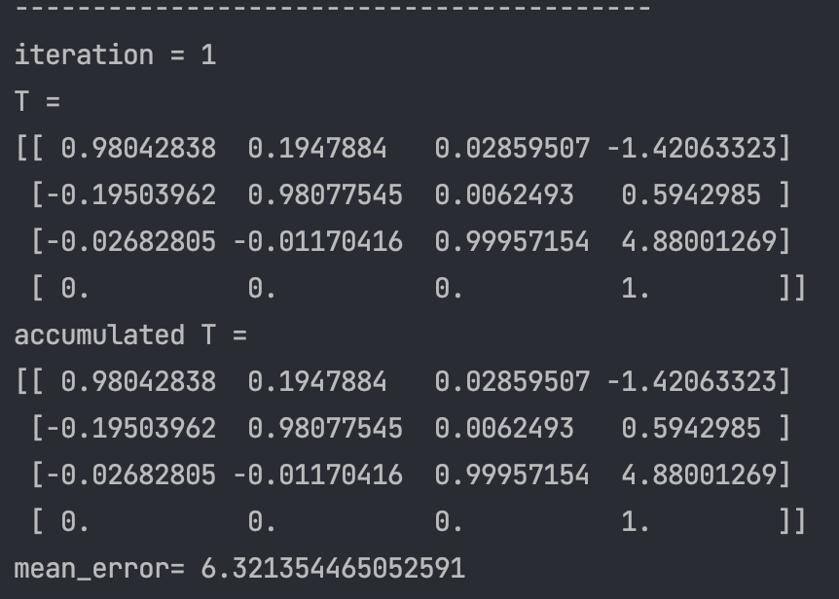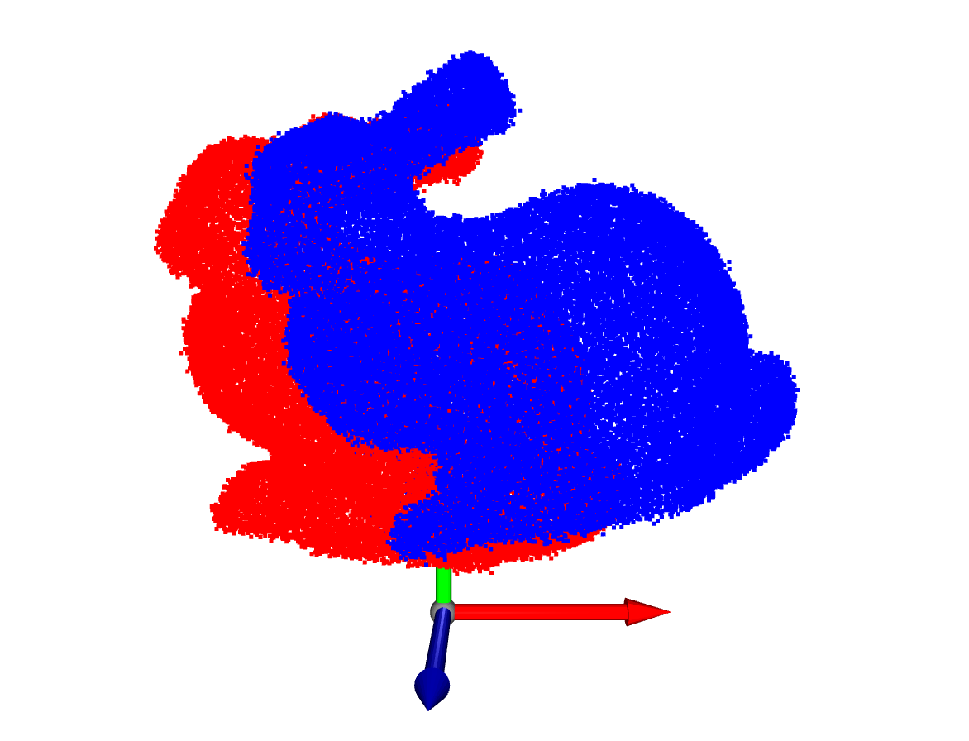

Figure 2.1 Iteration = 1

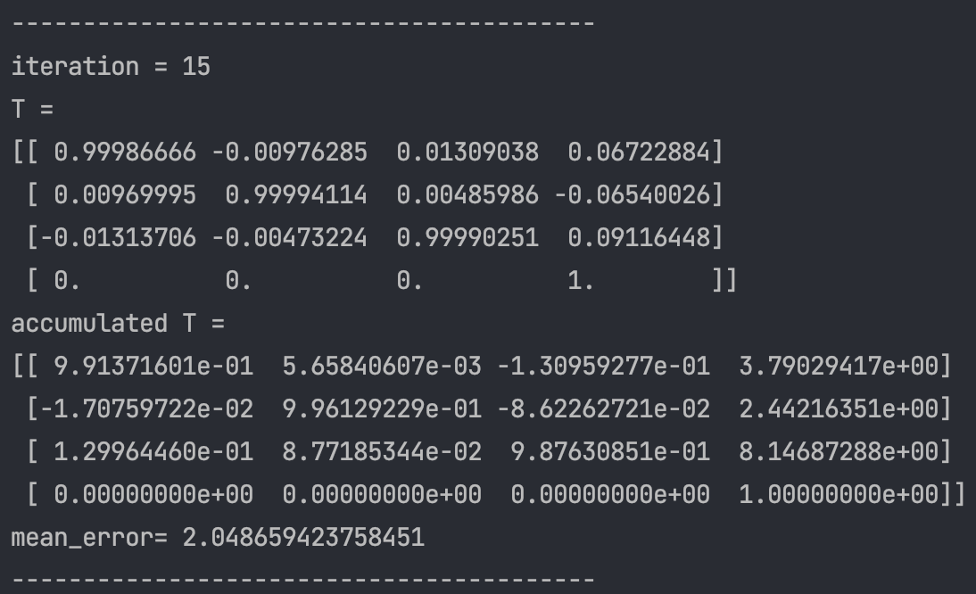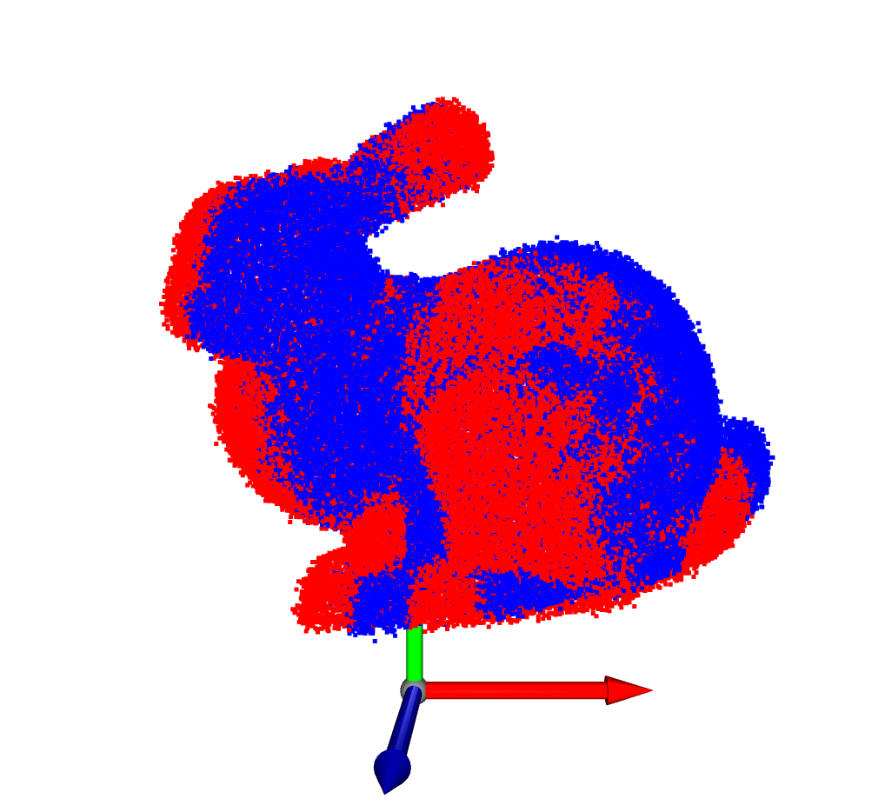

Figure 2.2 Iteration = 15

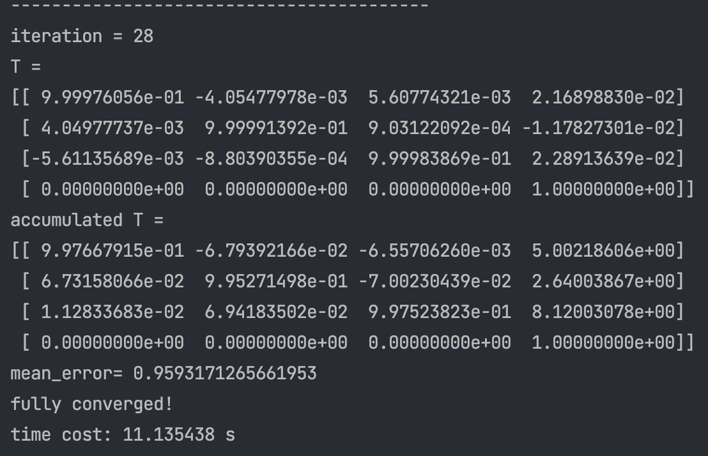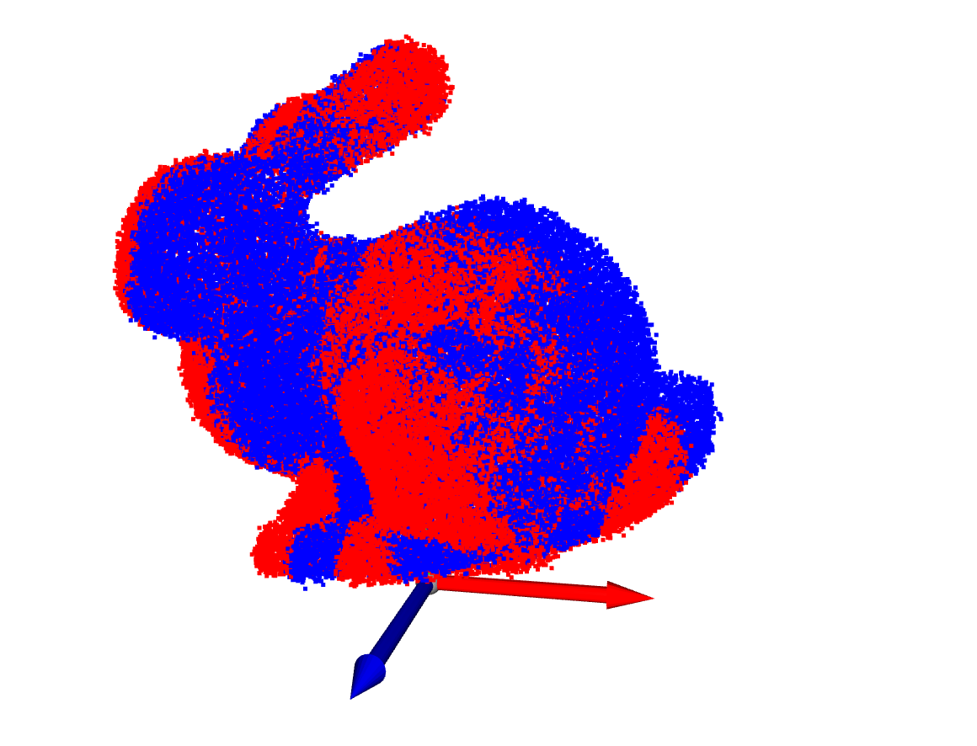

Figure 2.3 Iteration = 28

**Task 3: Running SLAM Algorithms**

To achieve 2D SLAM, use the Cartographer (2D LiDAR) algorithm to run rosbag. Here are some basic steps:

1. Install the Cartographer ROS software package: Install the Cartographer ROS software package in the terminal

2. Clone Cartographer ROS source code

3. Install dependencies

4. Compile Cartographer ROS

5. Run Cartographer ROS: In this step, I modified the three files in the 2D SLAM algorithm routine, demo_backpack_2d.launch, bacpack_2d.launch, backpack_2d.lua (it is worth noting that the parameters in lua need to be adjusted according to the actual situation Modify for example we are using no multi-threaded radar, so the port should be set to closed)

6. Evaluate algorithm performance: Use the evo_ape command in the EVO toolbox to evaluate algorithm performance. Pass the full path to the rosbag file, the reference trajectory (/odom) and the estimated trajectory (/tf:odom.base_footprint and /tf:map.base_footprint) as arguments to the evo_ape command.

This will calculate the absolute RMSE between the reference and estimated trajectories and generate a performance evaluation report.

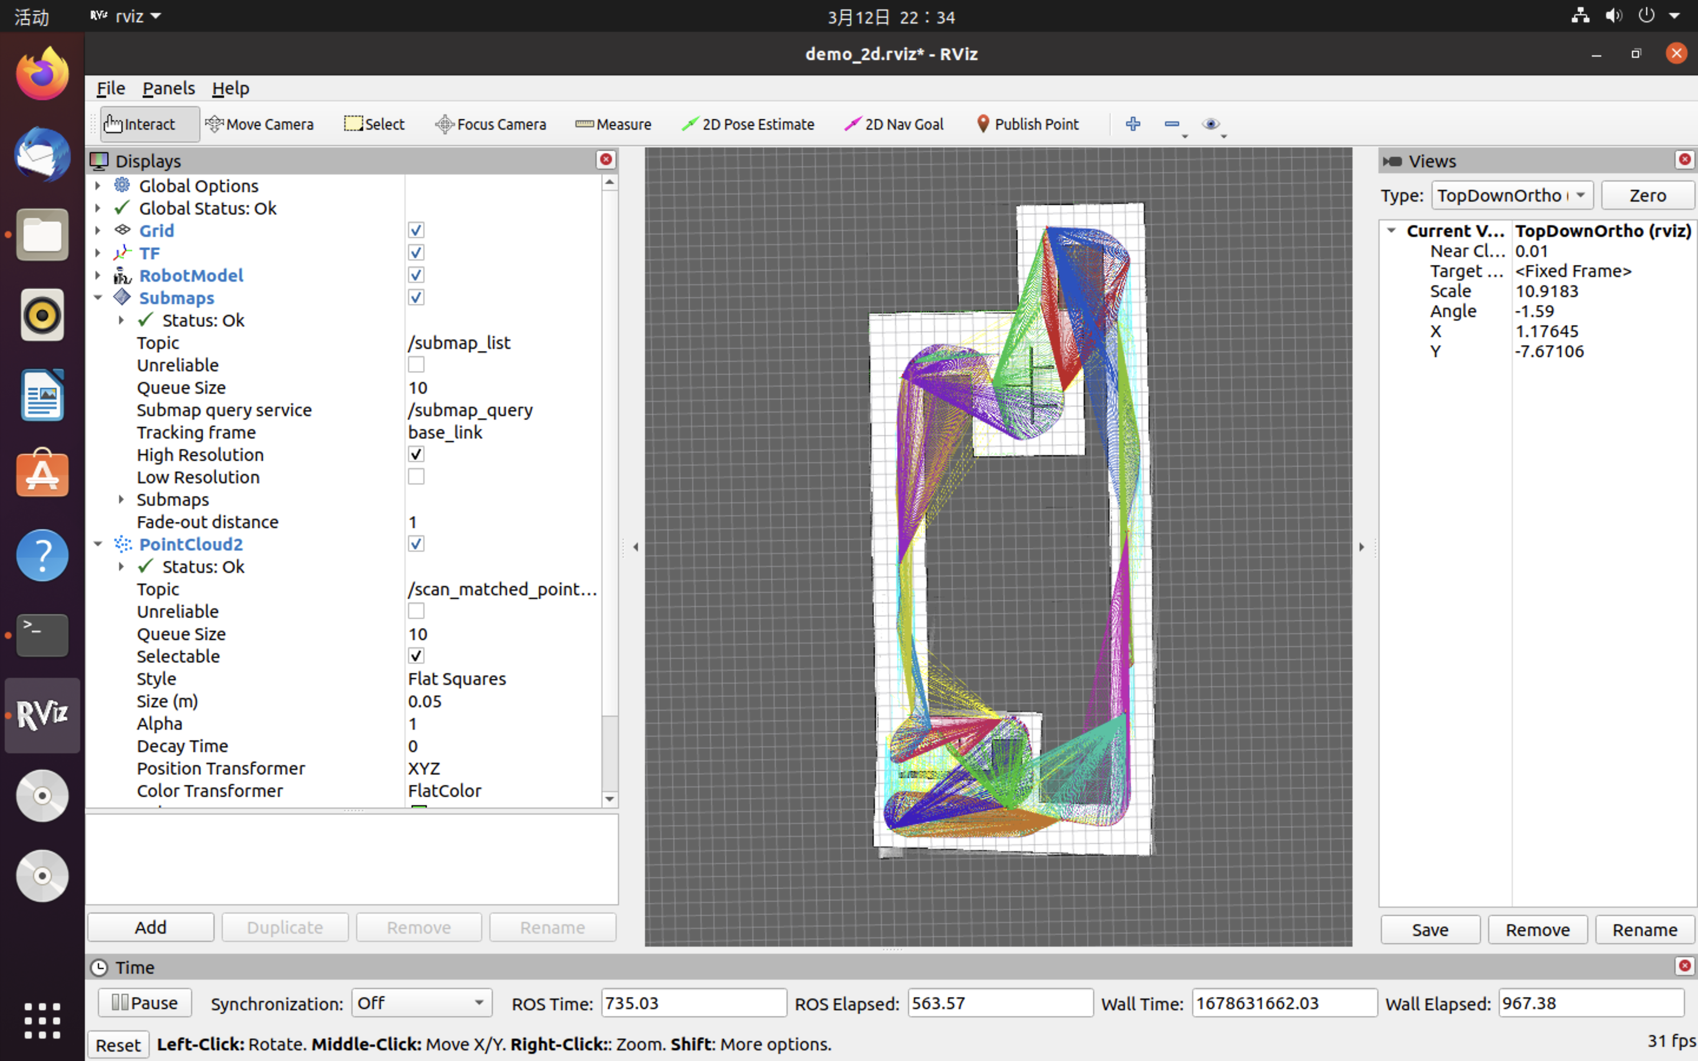

Figure 3.1.1 Real-time display of the mapping process in RVIZ

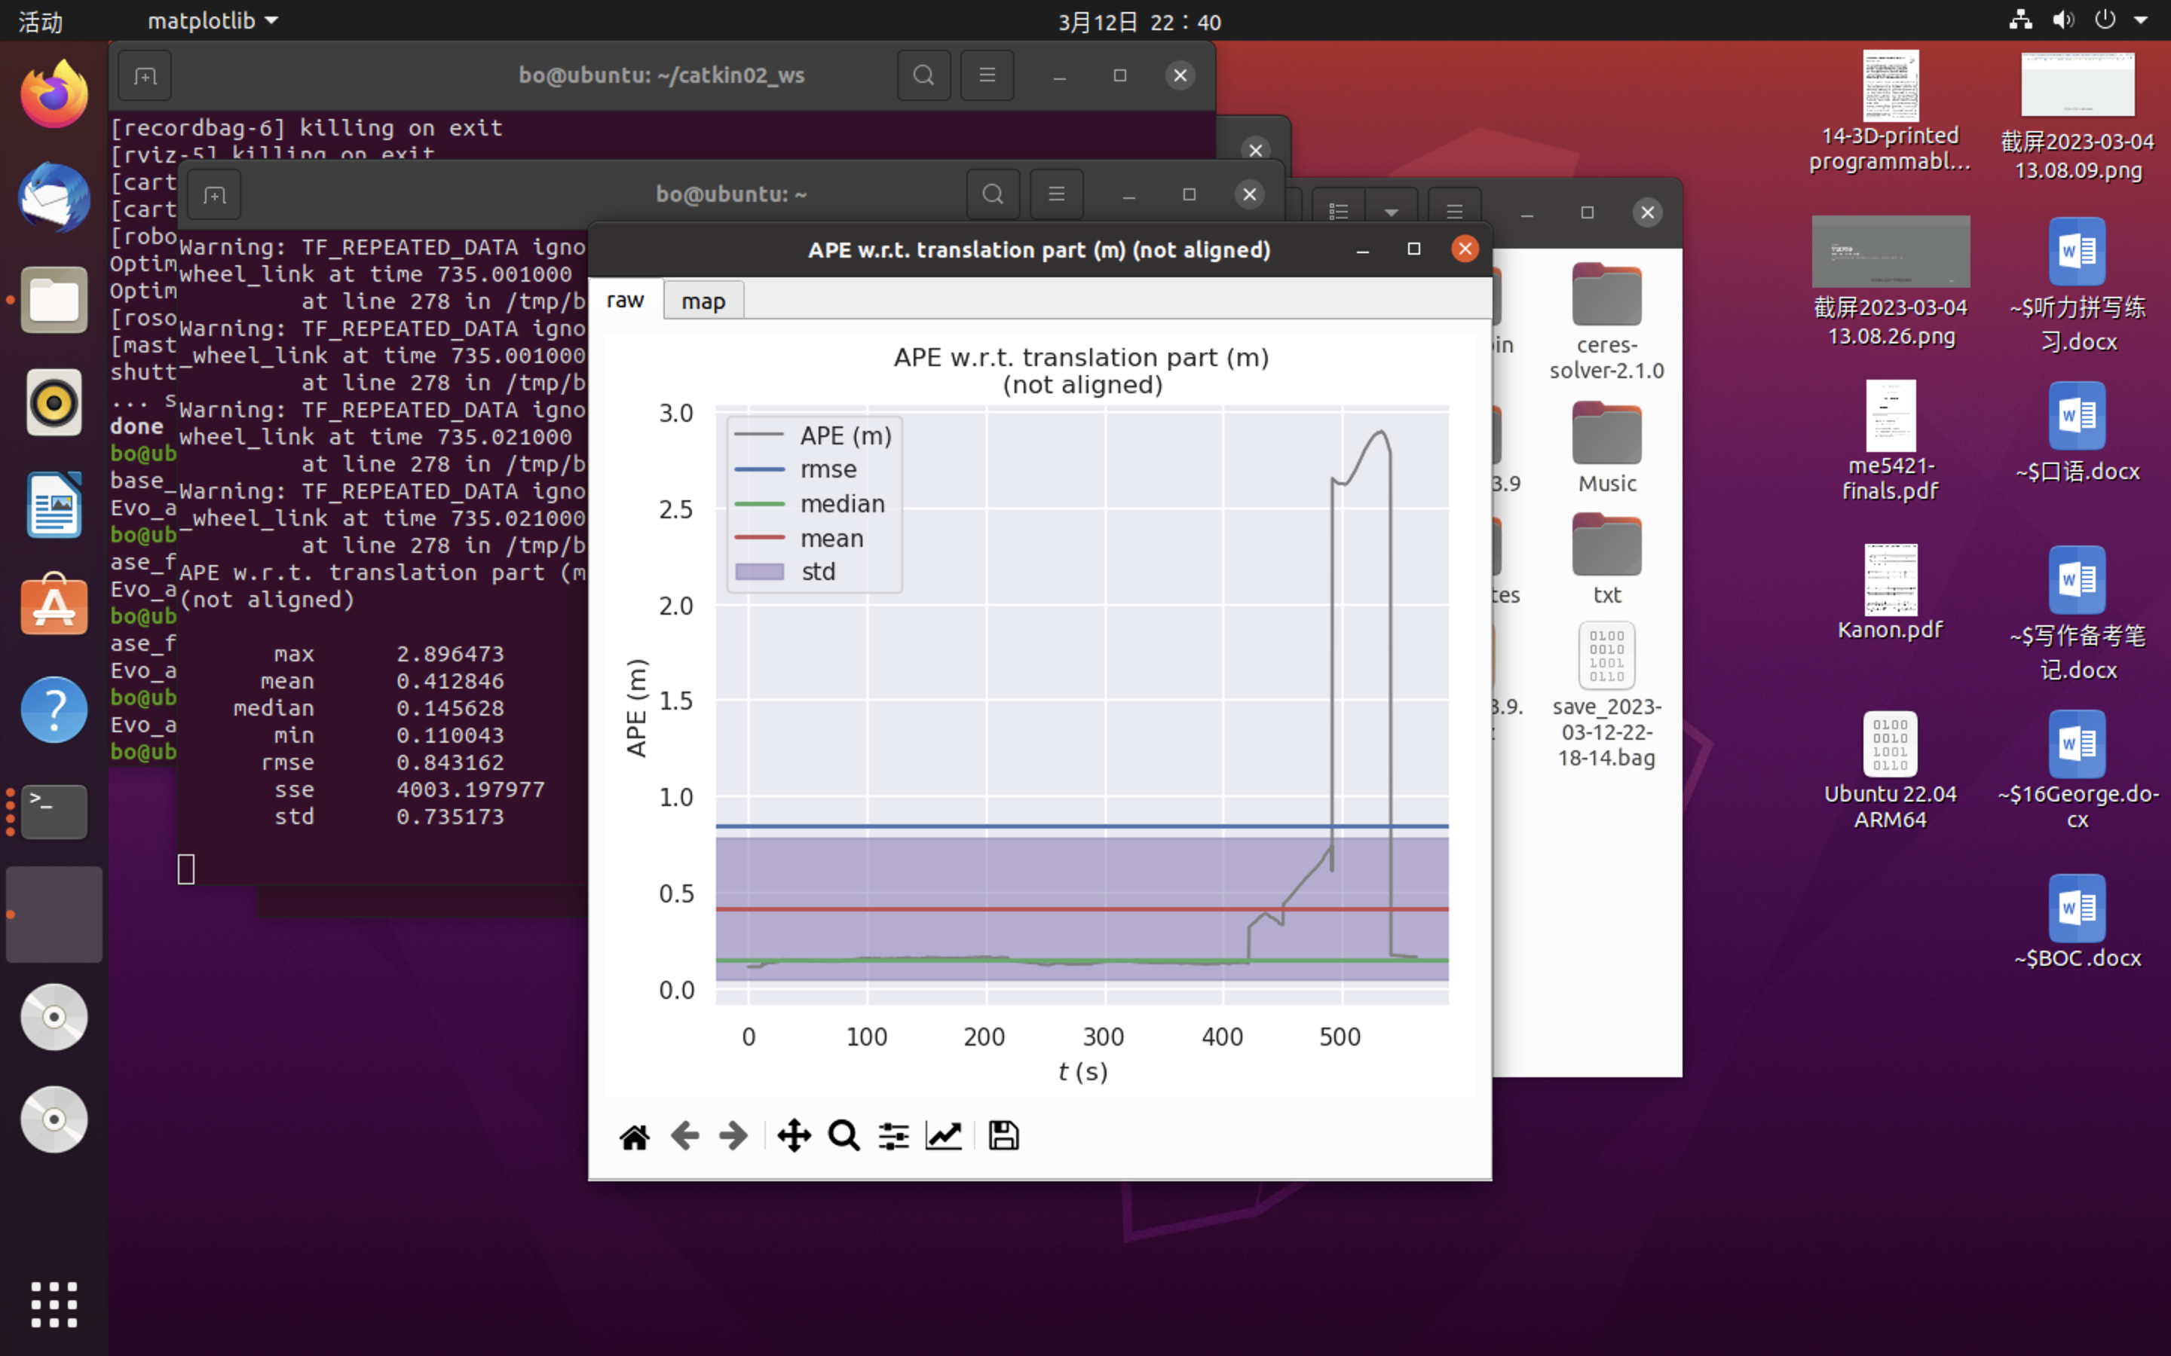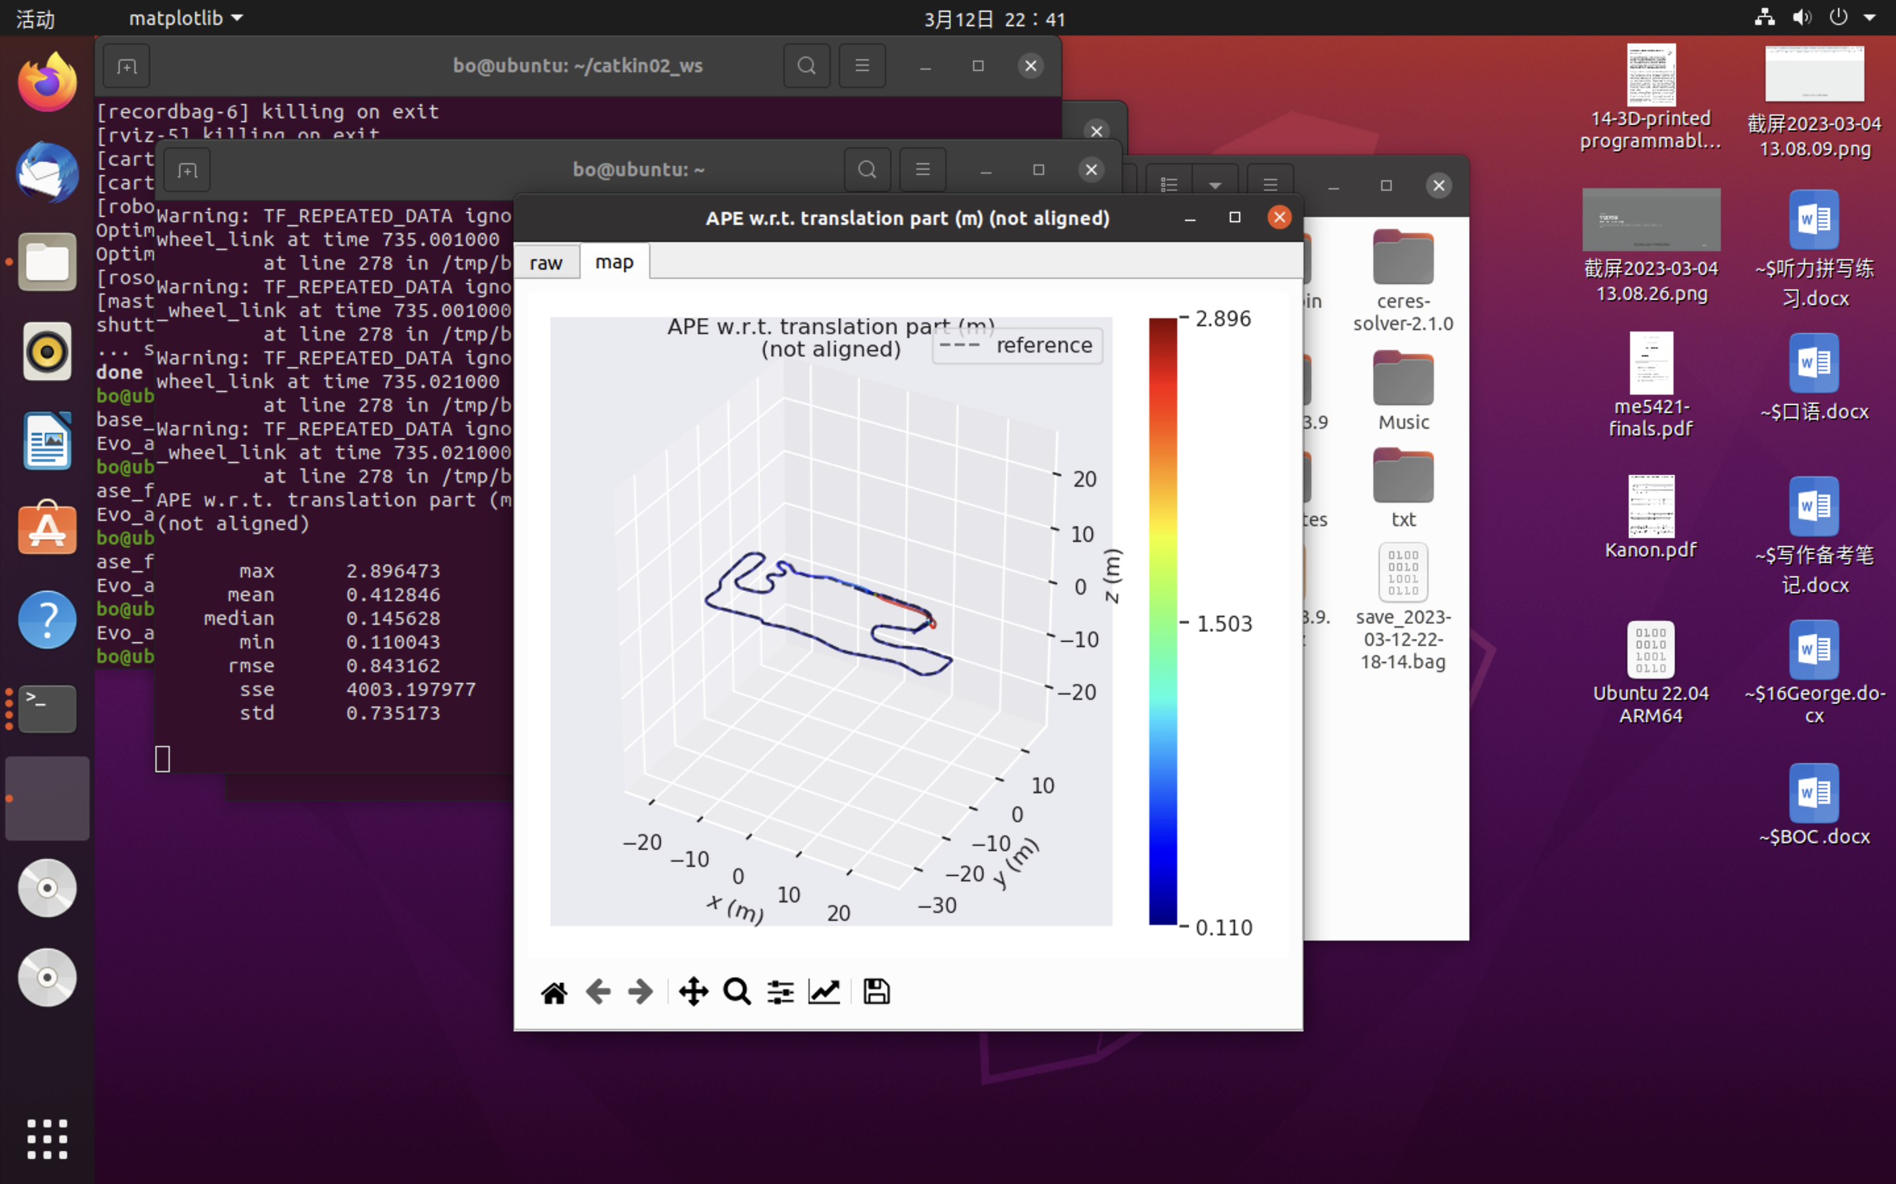

Figure 3.1.2 Run the EVO assessment

**3d**

1、After installation and compilation, run Aloam:



Figure 3.2.1 Run Aloam

2、Then play bag：

3、After execution, obtain the running trajectory graph:

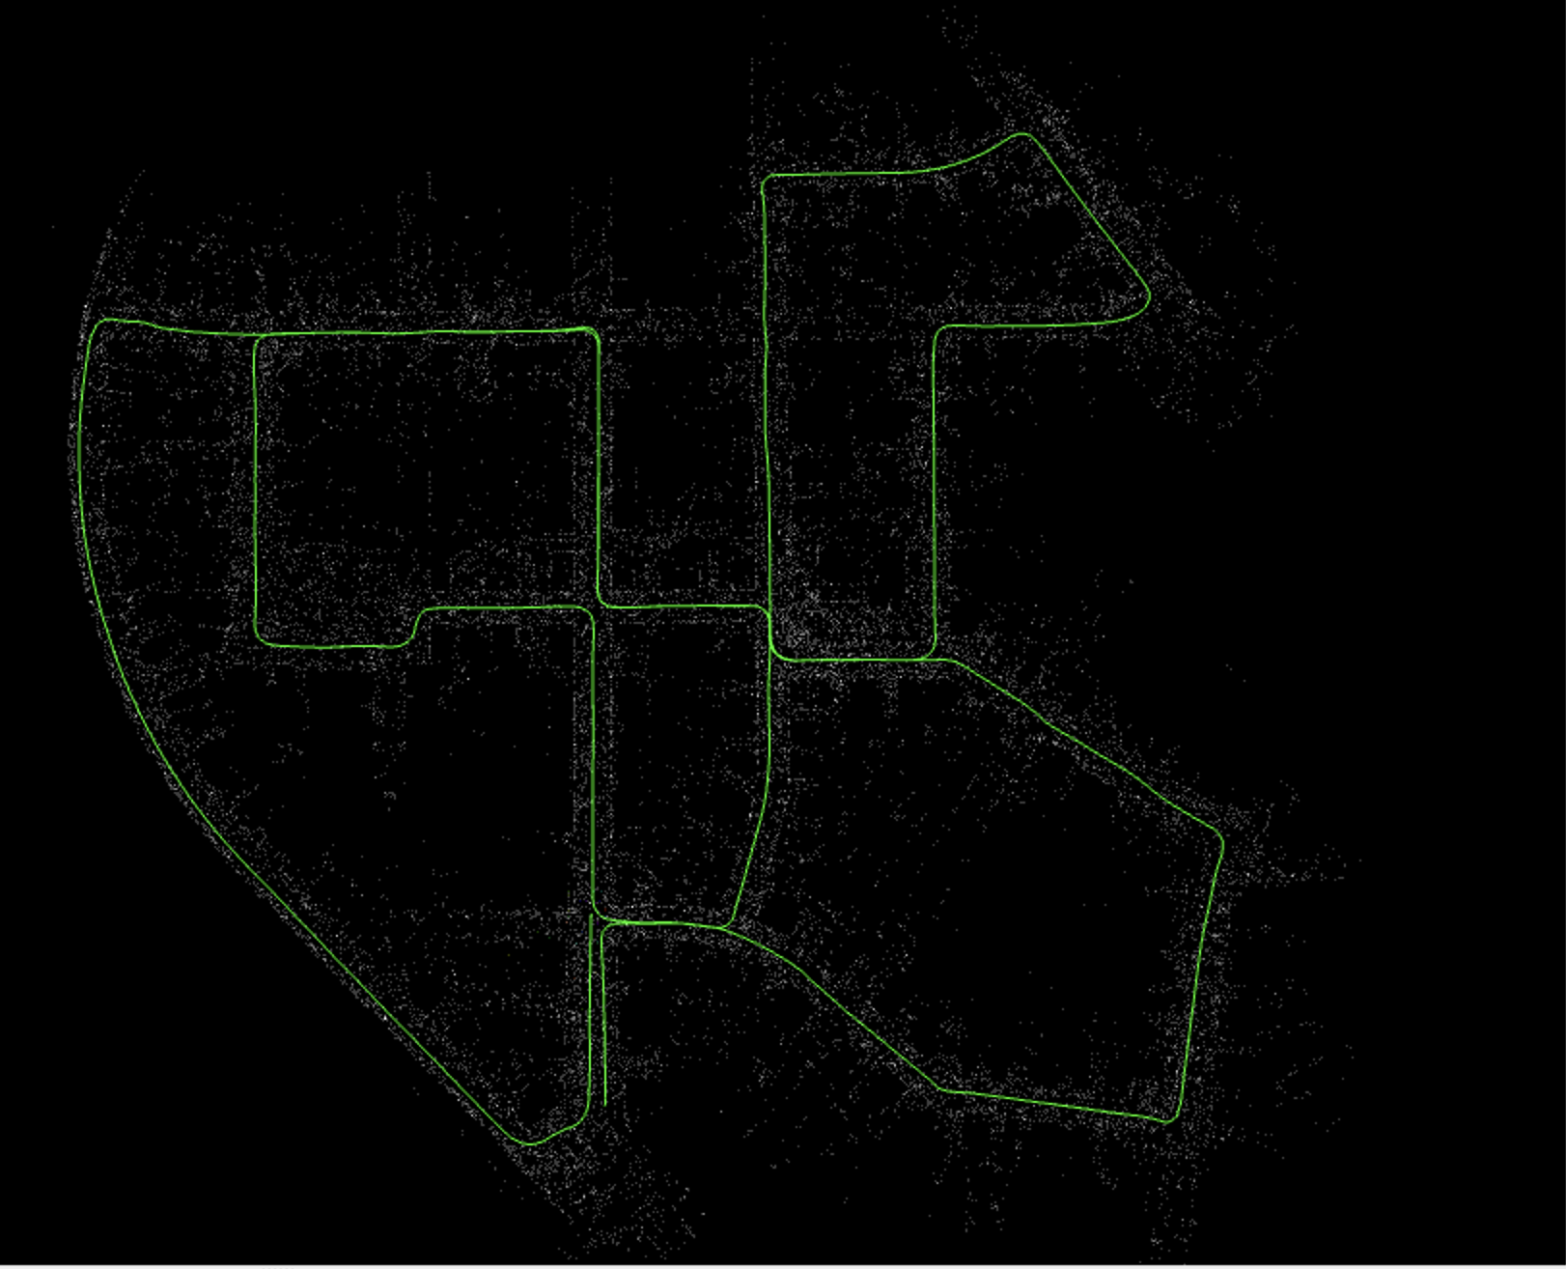

Figure 3.2.3 The running trajectory graph

（4）Compare the obtained trajectory with the ground truth using evo：

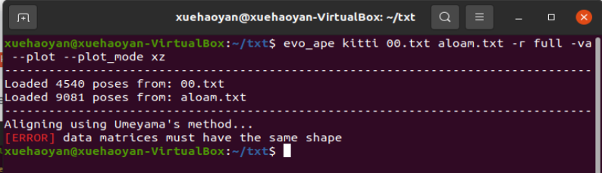

Figure 3.2.4 The problem

There was an issue with the comparison as the number of points in the generated txt did not match the ground truth. It is necessary to adjust the point count to be the same in both txts:

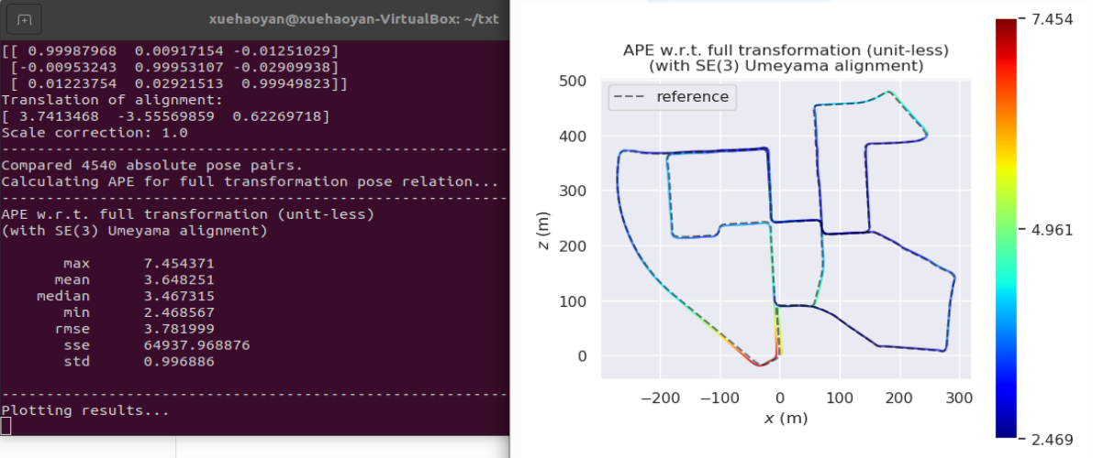

Figure 3.2.5 The evo comparison

**Task bonus**

In the bonus task, due to the environmental problems, the visualization is not actually realized, so briefly explain the two algorithms

Both VINS (Visual-Inertial Navigation System) and FAST-LIO (Fast LiDAR Odometry) are advanced SLAM algorithms that can achieve high-precision and high-efficiency positioning and mapping in various environments and scenarios.

VINS is a multi-sensor fusion SLAM algorithm that combines data from visual and inertial sensors for localization and mapping. The image of the scene is acquired through a visual sensor (such as a camera), and the pose and velocity information of the camera is obtained by using an IMU (inertial measurement unit). VINS fuses these data, uses an optimization algorithm to estimate the trajectory of the camera and the structure of the 3D scene, and achieves high-precision SLAM.

FAST-LIO is a lidar-based SLAM algorithm that uses LiDAR sensors to obtain three-dimensional information of the scene. FAST-LIO processes and optimizes the lidar data in real time, estimates the pose and velocity information of the robot, and generates a scene map. Compared with traditional filter-based methods, FAST-LIO adopts a faster scan-matching algorithm and a more effective optimization strategy, thereby achieving higher accuracy and faster speed.